Project Design Phase-II
Data Flow Diagram & User Stories

Date | 31 January 2025
Team ID
Project Name
Maximum Marks | 4 Marks

Data Flow Diagrams:
A Data Flow Diagram (DFD) represents how the electricity consumption data moves through our system, from raw ingestion to the final web display.
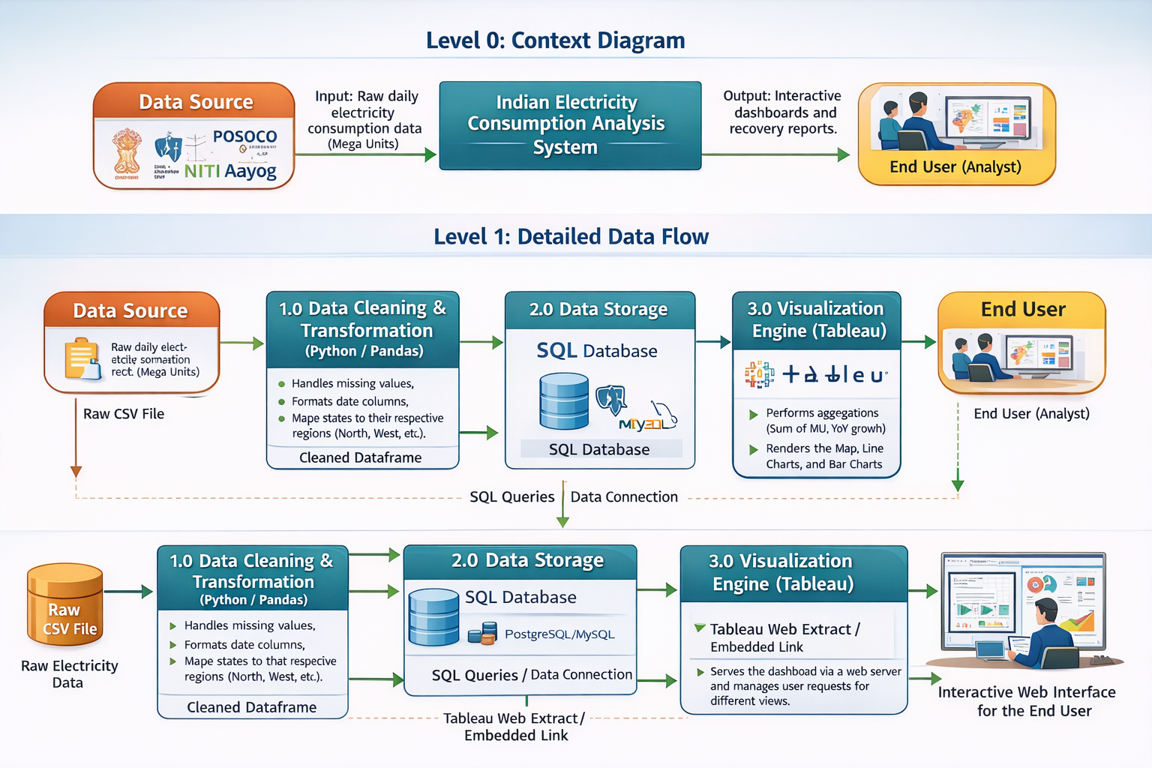

User Stories
Use the below template to list all the user stories for the product.
User Type | Functional Requirement (Epic) | User Story Number | User Story / Task | Acceptance Criteria | Priority | Release
Data Analyst | Data Integration | USN-1 | As an analyst, I want to store consumption data in a SQL database instead of CSV. | Data can be queried via SQL with 100% record count matching. | High | Sprint-1
Policy Maker | National Mapping | USN-2 | As a policymaker, I want to see a geographic map of India color-coded by energy usage. | Users can hover over a state to see specific Mega Unit (MU) values. | High | Sprint-1
Research Lead | Trend Analysis | USN-3 | As a researcher, I want to compare 2019 vs 2020 daily demand on a single chart. | The "Lockdown Dip" (March-June) must be clearly visible via dual axes. | High | Sprint-1
Field Officer | Web Accessibility | USN-4 | As a field officer, I want to access the dashboard via a standard web browser. | The dashboard must load within a Flask-hosted URL without Tableau Desktop. | Medium | Sprint-2
System Admin | Performance | USN-5 | As an admin, I want the dashboard to load in under 3 seconds despite the 16k+ rows. | Dashboard remains responsive when switching between regional filters. | Medium | Sprint-2

:

